CHAPTER 3

3.1 Time Complexity Analysis: Asymptotic notation

The order of growth of the running time of an algorithm gives a simple characterization of the algorithm's efficiency.

Also, the order of growth of the running time of an algorithm allows us to compare the relative performance of alternative algorithms.

Once the input size n becomes large enough, merge sort worst-case running time, beats insertion sort worst-case running time.

Although we can sometimes determine the exact running time of an algorithm, the extra precision is not usually worth the effort of computing it.

For large enough inputs, the multiplicative constants and lower-order terms of an exact running time are dominated by the effects of the input size itself.

When we look at input sizes large enough to make only the order of growth of the running time relevant, we are studying the asymptotic efficiency of algorithms.

That is, we are concerned with how the running time of an algorithm increases with the size of the input in the limit, as the size of the input increases without bound.

Usually, an algorithm that is asymptotically more efficient will be the best choice for all but very small inputs.

The notations we use to describe the asymptotic running time of an algorithm are defined in terms of functions whose domains are the set of natural numbers N = {0, 1, 2,...}.

Such notations are convenient for describing the worst-case running-time function T(n), which is usually defined only on integer input sizes.

It is sometimes convenient, however, to abuse asymptotic notation in a variety of ways.

For example, the notation is easily extended to the domain of real numbers or, alternatively, restricted to a subset of the natural numbers.

It is important, however, to understand the precise meaning of the notation so that when it is abused, it is not misused.

The Big O-notation (Big Oh)

When we have only an asymptotic upper bound, we use the Big Oh, the O-notation.

Definition: For a given function g(n), we denote by O(g(n)), read big Oh of g(n), or O of g(n), or order of g(n), the set of functions:

{f(n) | there exist positive constants c and n₀ such that 0 ≤ f(n) ≤ cg(n) for all n ≥ n₀} = O(g(n)).

We use O-notation to give an upper bound on a function, to within a constant factor.

Figure 3.1 below shows the intuition behind O-notation.

For all values n to the right of n₀, the value of the function f(n) is on or below g(n).

To indicate that a function f(n) is a member of O(g(n)), we write f(n) = O(g(n)).

cg(n)
f(n)
Figure 3.1 f(n) = Ο(g(n))
n
n₀

What may be rather surprising is that any linear function an + b is in O(n²), which is easily verified by taking c = a + |b| and n₀ = 1.

Some readers who have seen O-notation before may find it strange that we should write, for example, n = O(n²).

In this notes, however, when we write

f(n) = O(g(n))

we are merely claiming that, some constant multiple of g(n) is an asymptotic upper bound on f(n), with no claim about how tight an upper bound it is.

Distinguishing asymptotic upper bounds from now become standard in the algorithms literature.

Using O-notation, we can often describe the running time of an algorithm merely by inspecting the algorithm's overall structure.

For example, the triply nested loop structure of the following algorithm:

for (i = 1; i ≤ n; i++)
for (j = 1; j ≤ n; j++)
for (k = 1; k ≤ n; k++)
linear statements (no loops)
end for
end for
endfor

immediately yields an O(n³) upper bound on the worst-case running time: the cost of the i-loop is bounded from above by O(n), the cost of the j-loop is bounded from above by O(n), therefore the cost of both loops together is bounded by O(n²), and so on.

Since O-notation describes an upper bound, when we use it to bound the worst-case running time of an algorithm, by implication we also bound the running time of the algorithm on arbitrary inputs as well.

Thus, the O(n²) bound on worst-case running time of insertion sort also applies to its running time on every input.

Technically, it is an abuse to say that the running time of insertion sort is O(n²), since for a given n, the actual running time depends on the particular input of size n.

That is, strictly speaking, the running time is not really a function of n.

What we mean when we say "the running time is O(n²)" is that the worst-case running time (which is a function of n) is O(n²), or equivalently, no matter what particular input of size n is chosen for each t value of n, the running time on that set of inputs is O(n²).

Examples of Big O Calculations

Example 1: Prove that in T(n) = (n+1)² is O(n²).
Proof: We can see that
T(n) = n² + 2n +1 ≤ n² + 2n² + n² = 4n² for n = n₀ ≥ 1.
We have found the constant c = 4 and the value of n₀ which is for n₀ ≥ 1.

Example 2: Prove that 3^{n} is not O(2^{n})

Proof: We need to show that there are constants c and n0 such that 3^{n} ≤ c*2^{n} for n ≥ n₀. That is we need to have a c such that c ≥ (3/2)^{n} for any n ≥ n₀. But (3/2)^{n} grows arbitrarily as n gets large, so no constant c can be larger than the exponential for all n.

Example 3: Let T₁(n) = O(f(n)) and T₂(n) = O(g(n)) be the running times of two sub-programs P₁ and P₂ of a program P. Then the running time of P₁ followed P₂ is T₁(n) + T₂(n) = T(n).
Prove that T(n) = O(max(f(n) + g(n))

Proof: We have that:
T₁(n) ≤ c₁*f(n) for n ≥ n₁.
T₂(n) ≤ c₂*g(n) for n ≥ n₂.
Now let n₀ ≥ max(n₁, n₂), then
T(n) = T₁(n) + T₂(n) ≤ c₁*f(n) + c₂*g(n)
yields:
T(n) ≤ (c₁+ c₂)*max(f(n), g(n)) for n ≥ n₀, that is
T(n) = O(max(f(n), g(n))
This is called rule of sums!

Example 4:
Consider the subprograms whose running times are, respectively O(n²), O(n lg n) and O(n³). Then the running time of the first two subprograms running sequentially is O(max(n², n lg n) = O(n²). The running time of all three programs running together is O(max(n², n lg n, n³) = O(n³).

Example 5:
Consider the following times running together:
f(n) = n⁴ if n is even and n² if n is odd
g(n) = n² if n is even and n³ if n is odd
In this case the sum rule applies to f(n) + g(n) where O(max(f(n),g(n)) is n⁴ if n is even and n³ if n is odd.

In a similar way we can prove the rule for products: If T₁(n) is O(f(n)) and T₂(n) is O(G(n)), then T₁(n)*T₂(n) is O(f(n)*g(n)).

Ω-notation (Omega)

Just as O-notation provides an asymptotic upper bound on a function, Ω-notation provides an asymptotic lower bound.

Definition: For a given function g(n), we denote by Ω(g(n)) the set of functions

{f(n) | there exist positive constants c and n₀ such that 0 ≤ cg(n) ≤ f(n) for all n ≥ n₀} = Ω(g(n)).

The intuition behind Ω-notation is shown in Figure 3.2 below. For all values n to the right of n₀, the value of f(n) is on or above g(n).
cg(n)
f(n)
Figure 3.2 f(n) = Ω(g(n))
n
n₀

Since Ω-notation describes a lower bound, when we use it to bound the best running time of the algorithm, by implication we also bound the running time of the algorithm on arbitrary inputs as well.

For example, the best-case running time of insertion sort is Ω(n), which implies that the running time of insertion sort is Ω(n).

The running time of insertion sort therefore falls between Ω(n) and O(n²), since it falls anywhere between a linear function of n and a quadratic function of n.

Moreover, these bounds are asymptotically as tight as possible: for instance, the running time of insertion sort is not Ω(n²), since insertion sort runs in Ω(n) time when the input is already sorted.

It is not contradictory, however, to say that the worst-case running time of insertion sort is Ω(n²),since there exists an input that causes the algorithm to take Ω(n²) time.

When we say that the running time (no modifier) of an algorithm is Ω(g(n)), we mean that no matter what particular input of size n is chosen for each value of n, the running time on that set of inputs is at least a constant times g(n), for sufficiently large n.

Θ - notation (theta)

The Θ-notation asymptotically bounds a function from above and below. For a given function g(n), we denote by Θ(g(n)) (theta of g(n)) the set of functions

{f(n) | there exist positive constants c₁, c₂, and n₀ such that 0 ≤ c₁g(n) ≤ f(n) ≤ c₂g(n) for all n ≥ n₀} = Θ(g(n)).

A function f(n) belongs to the set Θ(g(n)) if there exist positive constants c₁ and c₂ such that it can be "sandwiched" between c₁g(n) and c₂g(n), for sufficiently large n.

Although Θ(g(n)) is a set, we write "f(n) = Θ(g(n))" to indicate that f(n) is a member of Θ(g(n)), or "f(n) ∈ Θ(g(n))."

This abuse of equality to denote set membership may at first appear confusing, but we shall see later in this section that it has advantages.

Figure 3.3 below gives an intuitive picture of functions f(n) and g(n), where f(n) = Θ(g(n)).

For all values of n to the right of n₀, the value of f(n) lies at or above c₁g(n) and at or below c₂g(n).

In other words, for all n ≥ n₀, the function f(n) is equal to g(n) to within a constant factor.

We say that g(n) is an asymptotically tight bound for f(n).
c₂g(n)
c₁g(n)
f(n)
Figure 3.3 f(n) = Θ(n)g(n)
n
n₀

The definition of Θ(g(n)) requires that every member of Θ(g(n)) be asymptotically nonnegative, that is, that f(n) be nonnegative whenever n is sufficiently large.

Consequently, the function g(n) itself must be asymptotically nonnegative, or else the set Θ(g(n)) is empty.

We shall therefore assume that every function used within Θ-notation is asymptotically nonnegative.

This assumption holds for the other asymptotic notations defined earlier as well.

Note that f(n) = Θ(g(n)) implies f(n) = O(g(n)), since Θ-notation is a stronger notion than O-notation.

Written set-theoretically, we have Θ(g(n)) 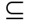 O(g(n)).

Thus, our proof that any quadratic function an² + bn + c, where a > 0, is in Θ(n²) also shows that any quadratic function is in O(n²).

In the literature, O-notation is sometimes used informally to describe asymptotically tight bounds, that is, what we have defined using Θ-notation.

The Θ(n²) bound on the worst-case running time of insertion sort, however, does not imply a Θ(n²) bound on the running time of insertion sort on every input.

In fact when the input is already sorted, insertion sort runs in Θ(n) time.

From the definitions of the asymptotic notations we have seen thus far, it is easy to prove the following important theorem.

Theorem 3.1

For any two functions f(n) and g(n), f(n) = Θ(g(n)) if and only if f(n) = O(g(n)) and f(n) = Ω(g(n)).

As an example of the application of this theorem, our proof that an² + bn + c = Ω(n²) for any constants a, b, and c, where a > 0, immediately implies that

an² + bn + c = Ω(n²) and an² + bn + c = O(n²).

In practice, rather than using Theorem 3.1 to obtain asymptotic upper and lower bounds from asymptotically tight bounds, as we did for this example, we usually use it to prove asymptotically tight bounds from asymptotic upper and lower bounds.

Example
Show that 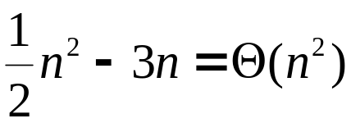

We must determine positive constants c₁, c₂, and no such that

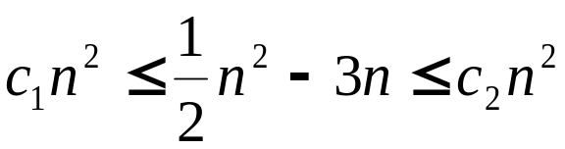

for all n ≥ n₀. Dividing by n² yields 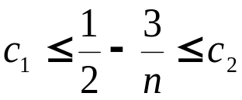
The right-hand inequality can be made to hold for any value of n ≥ 1 by choosing c₂ ≥ 1/2. Now let’s write
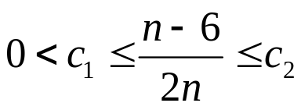and for these quantities to be positive we must have n > 6. Therefore the left-hand inequality can be made to hold for any value of n ≥ 7 by choosing c₁ ≤ 1/14.

Thus, by choosing c₁ = 1/14, c₂ = 1/2 and n₀ ≥ 7, we can verify that
.

Certainly, other choices for the constants exist, but the important thing is that some choice exists.

Note that these constants depend on the function
½ n² - 3n; a different function belonging to Θ(n²) would usually require different constants.

We can also use the formal definition to verify that
6n³ ≠ Θ(n²).

Suppose for the purpose of contradiction that c₂ and n₀ exist such that 6n³ ≤ c₂ n² for all n ≥ n₀.

But then n ≤ c₂/6, which cannot possibly hold for arbitrarily large n, since c₂ is constant.

Intuitively, the lower-order terms of an asymptotically positive function can be ignored in determining asymptotically tight bounds because they are insignificant for large n.

A tiny fraction of the highest-order term is enough to dominate the lower-order terms.

Thus, setting c₁ to a value that is slightly smaller than the coefficient of the highest-order term and setting c₂ to a value that is slightly larger permits the inequalities in the definition of Θ-notation to be satisfied.

The coefficient of the highest-order term can likewise be ignored, since it only changes c₁ and c₂ by a constant factor equal to the coefficient.

As an example, consider any quadratic function

f(n) = an² + bn + c, where a, b, and c are constants and a > 0.

Throwing away the lower-order terms and ignoring the constant yields f(n) = Θ(n²).

Formally, to show the same thing, we take the constants c₁ = a/4, c₂ = 7a/4, and 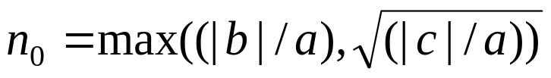.

You may verify that

0 ≤ c₁n² ≤ an² + bn + c ≤ c₂n² for all n ≥ n₀.

In general, for any polynomial 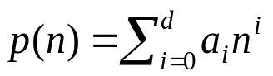, where the a_{i} are constants and a_{d} > 0, we have p(n) = Θ(n^{d}).

Since any constant is a degree 0 polynomial, we can express any constant function as Θ(n⁰), or Θ(1).

This latter notation is a minor abuse, however, because it is not clear what variable is tending to infinity.

We shall often use the notation Θ(1) to mean either a constant or a constant function with respect to some variable.

Asymptotic notation in equations

We have already seen how asymptotic notation can be used within mathematical formulas.

For example, in introducing O-notation, we wrote "n = O(n²)."

We might also write 2n² + 3n + 1 = 2n² + Θ(n).

How do we interpret such formulas?

When the asymptotic notation stands alone on the right-hand side of an equation, as in n = O(n²), we have already defined the equal sign to mean set membership: n ∈ O(n²).

In general, however, when asymptotic notation appears in a formula, we interpret it as standing for some anonymous function that we do not care to name.

For example, the formula

2n² + 3n + 1 = 2n² + Θ(n) means that

2n² + 3n + 1 = 2n² + f(n),

where f(n) is some function in the set Θ(n).

In this case, f(n) = 3n + 1, which indeed is in Θ(n).

Using asymptotic notation in this manner can help eliminate inessential detail and clutter in an equation.

For example, we can express the worst-case running time of merge sort as the recurrence

T(n) = 2T(n/2) + Θ(n) .

If we are interested only in the asymptotic behavior of T(n), there is no point in specifying all the lower-order terms exactly; they are all understood to be included in the anonymous function denoted by the term Θ(n).

The number of anonymous functions in an expression is understood to be equal to the number of times the asymptotic notation appears.

For example, in the expression
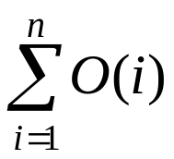
there is only a single anonymous function (a function of i).

This expression is thus not the same as

O(1) + O(2) + . . . +O(n),

which doesn't really have a clean interpretation.

In some cases, asymptotic notation appears on the left-hand side of an equation, as in

2n² + Θ(n) = Θ(n²).

We interpret such equations using the following rule:

No matter how the anonymous functions are chosen on the left of the equal sign, there is a way to choose the anonymous functions on the right of the equal sign to make the equation valid.

Thus, the meaning of our example is that for any function f(n) ∈ Θ(n), there is some function g(n) ∈ Θ(n²) such that 2n² + f(n) = g(n) for all n.

In other words, the right-hand side of an equation provides coarser level of detail than the left-hand side.

A number of such relationships can be chained together, as in
2n² + 3n + 1 = 2n² + Θ(n)
= Θ(n²) .

We can interpret each equation separately by the rule above.

The first equation says that (there is some function)

∃f(n) ∈ Θ(n) | 2n² + 3n + 1 = 2n² + f(n) ∀n.

The second equation says that (for any function)

∀g(n) ∈ Θ(n) ∃h(n) ∈ Θ(n²) | 2n² + g(n) = h(n) ∀n.

Note that this interpretation implies that 2n² + 3n + 1 = Θ(n²),

o-notation (Little oh)

The asymptotic upper bound provided by O-notation may or may not be asymptotically tight.

The bound 2n² = O(n²) is asymptotically tight, but the bound 2n = 0(n²) is not.

We use o-notation to denote an upper bound that is not asymptotically tight.

We formally define o(g(n)) ("little-oh of g of n") as the set

o(g(n)) = {f(n): for any positive constant c > 0, there exists a constant n₀ > 0 such that 0 ≤ f(n) < cg(n) for all n ≥ n0} .

For example, 2n = o(n²), but 2n² ≠ o(n²).

The definitions of O-notation and o-notation are similar.

The main difference is that in f(n) = O(g(n)), the bound 0 ≤ f(n) < cg(n) holds for some constant c > 0, but in f(n) = o(g(n)), the bound 0 ≤ f(n) < cg(n) holds for all constants c > 0.

Intuitively, in the o-notation, the function f(n) becomes insignificant relative to g(n) as n approaches infinity; that is, 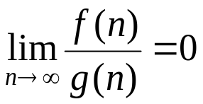

Some authors use this limit as a definition of the o-notation; the definition in this book also restricts the anonymous functions to be asymptotically nonnegative.

ω-notation (Little omega)

By analogy, ω-notation is to Ω-notation as o-notation is to O-notation.

We use ω-notation to denote a lower bound that is not asymptotically tight.

One way to define it is by

f(n) ∈ ω(g(n)) if and only if g(n) ∈ o(f(n))

Formally, however, we define ω(g(n)) ("little-omega of g of n") as the set

ω(g(n)) = {f(n) | for any positive constant c > 0, there exists a constant n₀ > 0 such that 0 ≤ cg(n) < f(n) for all n ≥ n₀}

For example, n²/2 = ω(n), but n²/2 ≠ ω(n²).

The relation f(n) = ω(g(n)) implies that

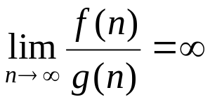 if the limit exists.

That is, f(n) becomes arbitrarily large relative to g(n) as n approaches infinity.

Comparison of functions

Many of the relational properties of real numbers apply to asymptotic comparisons as well. For the following, assume that f(n) and g(n) are asymptotically positive.

Transitivity:
f(n) = Θ(g(n)) and g(n) = Θ(h(n)) imply f(n) = Θ(h(n)),
f(n) = O(g(n») and g(n) = O(h(n)) imply f(n) = O(h(n)) ,
f(n) = Ω(g(n)) and g(n) = Ω(h(n)) imply f(n) = Ω(h(n)),
f(n) = o(g(n)) and g(n) = o(h(n)) imply f(n) = o(h(n)),
f(n) = ω(g(n)) and g(n) = ω(h(n)) imply f(n) = ω(h(n)) .

Reflexivity:
f(n) = Θ(f(n)),
f(n) = O(f(n)),
f(n) = Ω(f(n)).

Symmetry:
f(n) = Θ(g(n)) if and only if g(n) = Θ(f(n)) .

Transpose symmetry:
f(n) = O(g(n)) if and only if g(n) = Ω(f(n)) ,
f(n) = o(g(n)) if and only if g(n) = ω(f(n)).

Because these properties hold for asymptotic notations, one can draw an analogy between the asymptotic comparison of two functions f and g and the comparison of two real numbers a and b:

f(n) = O(g(n)) ≈ a ≤ b ,
f(n) = Ω(g(n)) ≈ a ≥ b ,
f(n) = Θ(g(n)) ≈ a = b ,
f(n) = o(g(n)) ≈ a < b ,
f(n)= ω(g(n)) ≈ a>b.

One property of real numbers, however, does not carry over to asymptotic notation:

Trichotomy: For any two real numbers a and b, exactly one of the following must hold: a < b, a = b, or a> b.

Although any two real numbers can be compared, not all functions are asymptotically comparable.

That is, for two functions f(n) and g(n), it may be the case that neither f(n) = O(g(n)) nor f(n) = Ω(g(n)) holds.

For example, the functions n and n^{l+sinn} cannot be compared using asymptotic notation, since the value of the exponent in n ^{l+sinn} oscillates between 0 and 2, taking on all values in between.

3.2 Calculating the Running Time of a Program

Before presenting these principles, it is important that we learn how to add and multiply in "big oh" notation.

Suppose that T₁(n) and T₂(n) are the running times of two program fragments P₁ and P₂, and that

T₁(n) is O(f(n)) and T₂(n) is O(g(n)).

Then T₁(n) + T₂(n), the running time of P₁ followed by P₂, is O(max(f(n), g(n)).

To see why, observe that for some constants c₁, c₂, n₁, and n₂,
if n ≥ n₁ then T₁ (n) ≤ c₁f(n),
and
if n ≥ n₂ then T₂(n) ≤ c₂g(n).

Let n₀ = max(n₁, n₂).

If n ≥ n₀, then T₁(n) + T₂(n) ≤ c₁f(n) + c₂g(n).

From this we conclude that if n ≥ n₀, then

T₁(n) + T₂(n) ≤ (c₁ + c₂)max(f(n), g(n)).

Therefore T₁(n) + T₂(n) is O(max(f(n), g(n)).

Example

The rule for sums given above can be used to calculate the running time of a sequence of program steps, where each step may be an arbitrary program fragment with loops and branches.

Suppose that we have three steps whose running times are, respectively,

O(n²), O(n³) and O(n log n).

Then the running time of the first two steps executed sequentially is O(max(n², n³) = O(n³).

The running time of all three together is

O(max(n³, n log n )) = O(n³).

In general, the running time of a fixed sequence of steps is, to within a constant factor, the running time of the step with the largest running time.

In rare circumstances there will be two or more steps whose running times are incommensurate (neither is larger than the other, nor are they equal).

For example, we could have steps of running times O(f(n)) and O(g(n)), where

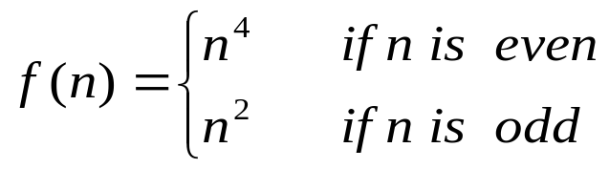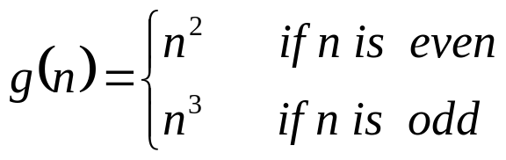

In such cases the sum rule must be applied directly; O(f(n) +O(g(n)) is O(max(f(n), g(n)), that is, n⁴ if n is even and n³ if n is odd.

Another useful observation about the sum rule is that if g(n) ≤ f(n) for all n above some constant n₀, then O(f(n) + g(n)) is the same as O(f(n)).

For example, O(n² + n) is the same as O(n²).

The rule for products is the following.

If T₁(n) and T₂(n) are O(f(n)) and O(g(n)), respectively, then T₁(n)T₂(n) is O(f(n)g(n)).

You should prove this fact using the same ideas as in the proof of the sum rule.

It follows from the product rule that O(cf(n)) means the same thing as O(f(n)) if c is any positive constant.

For example, O(n²/2) is the same as O(n²).

Note:
Part of the material that follows is standard College Algebra/Calculus or has already been covered in previous chapters of this class. (It can be skipped/briefly looked at).
Exercises Measuring Time Complexity:

Exercise 1.
Find the time complexity of the following algorithm:

begin
for i = 1 to n do
for j = 1 to n do begin
C[i, j] = 0;
for k = 1 to n do
C[i, j] = C[i, j] + A[i, k]*B[k, j]
end
end

Solution:

In this case it should be clear that the “k-loop” is O(n) since it executes n times. (In fact the “for” line executes once more but this is irrelevant for an “order of magnitude” measurement). Now the “j-loop” also executes n times and both loops together execute O(n²). Lastly, including the “i-loop” which also runs n times, all three loops together execute order O(n³). This is the Time Complexity of this algorithm.

Exercise 2.
Calculate in detail the time complexity of the following algorithm

begin
for i = 1 to n do
if odd(i) then begin
for j = i to n do
x = x + 1;
for j = 1 to i do
y = y + 1;
end
end

Solution:
We realize that the external loop, the i-loop”, executes n times (in fact the “for” line of code executes n+1 times). However the internal condition that n be odd makes the body of the first “for” loop execute only n/2 times (approximately). Therefore the two inner loops, the two “j-loops”, execute n/2 times. Since when evaluating the asymptotic order a constant is irrelevant (we know that O(n/2) and O(n) or for that matter any O(cn) are in fact all O(n)), then let’s just calculate as close as possible without thinking about the small details. If we call T(n) the total running time of this algorithm then:

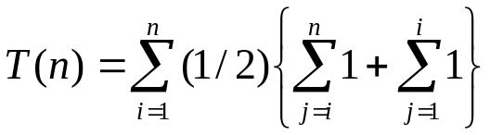
where the “1s” stand for the constants inside the loop (O(1)). The first internal sum can be divided into two sums: a sum from 1 to n minus a sum from 1 to i-1 (this makes the total sum from i to n. The second internal sum is just i – 1 + 1 = i. We have then:

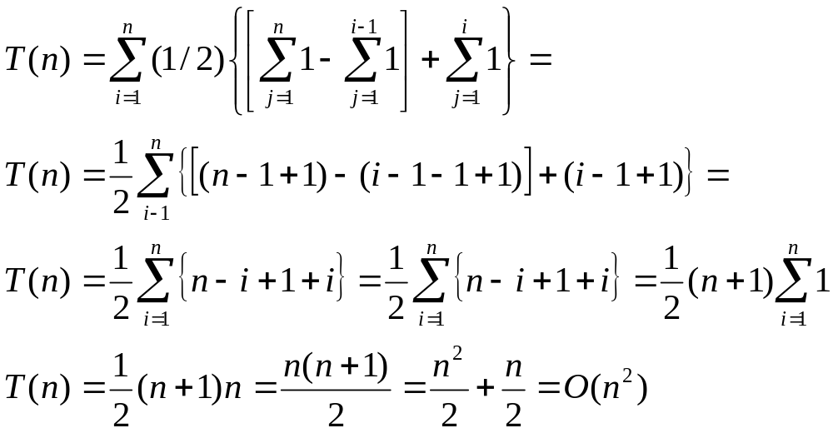

Exercise 3.
Prove that the following algorithm is O(n³)

begin
{some statements requiring O(1) time}
for i = 1 to n do
for j = i+2 to n do
for k = 1 to j do
{some statements requiring O(1) time}
{some statements requiring O(1) time}
end

Solution:
We proceed as in the last exercise:

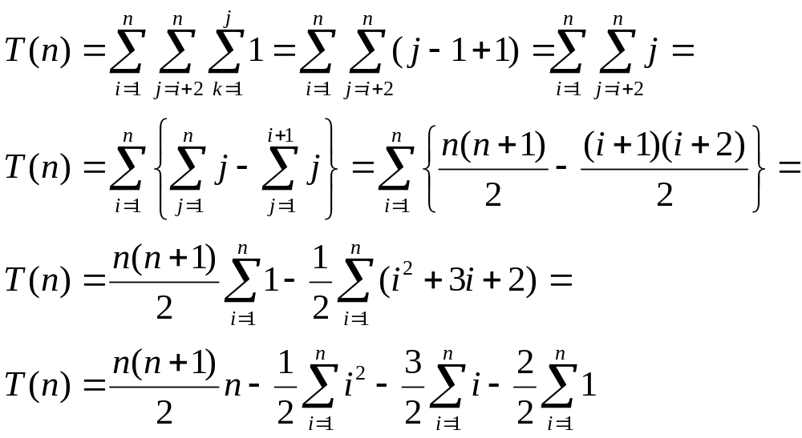
and the rest is just a trivial use of known formulas.

Exercise 4.

i = n
while (i >= 1) {
for j = 1 to i
x = x + 1 //O(1) statement
i = i/2
}

Solution:
We can see that initially i = n. Let’s make a table to “see” how the while loop works.

iteration  number | 1 | 2 | 3 | ....... | k
j = 1 to i | 1 to n | 1 to n/2 | 1 to n/2² | ....... | 1 to n/2^{k-1}
# of iterations  in the loop | n | n/2 | n/2² | ....... | n/2^{k-1}
Therefore the total number of iterations is:

T(n) = n + n/2 + n/2² + n/2³ + .... + n/2^{k-1} =
= n[1 + 1/2 + 1/2² + 1/2³ + .... + 1/2^{k-1}]

T(n) = n[1 - 1/2^{k}]/[1 – 1/2] = 2n[1 - 1/2^{k}]

Now, we assume that at the k^{th} iteration n was reduced to the minimum and that at the next iteration i was reduced to “slightly less than 1” and we can approximate that the while loop was exited when:

n/2^{k} = 1 => 2^{k} = n => k = lg n

and thus:

T(n) = 2n[1 – 1/n] = 2n – 1 = O(2n) = O(n)

Notice the difference between this exercise and the next.

Exercise 5
Assume now that the problem was:

i = n
while (i >= 1) {
for j = 1 to n
x = x + 1 //O(1) statement
i = i/2
}

Solution:
In this case the for loop inside the while loop always executes n times

iteration  number | 1 | 2 | 3 | ....... | k
value of i : | 1 to n | 1 to n/2 | 1 to n/2² | ....... | 1 to n/2^{k-1}
# of iterations  in the loop | n | n | n | ....... | n

Thus in total we have that there were n*k iterations. Therefore:
T(n) = n*k

Now, using the same assumption as in the previous exercise at the k^{th} kth iteration n was reduced to the minimum which in iterations is just ONE iteration, that is:

n/2^{k} = 1 => k = lg n.
Therefore:
T(n) = n*lg n) = O(n lg n)

Exercise 6
Assume now that the problem was:

i = n
while (i >= 1) {
for j = 1 to n
x = x + 1 //O(1) statement
i = i/3
}

Solution:
In this case proceed as before because this is just an equivalent exercise with different logs and with the loop stopping at n/3^{k} = 1.

Standard notations and common functions

This section reviews some standard mathematical functions and notations and explores the relationships among them. It also illustrates the use of the asymptotic notations.

Monotonicity

A function f(n) is monotonically increasing if m ≤ n implies f(m) ≤ f(n).

Similarly, it is monotonically decreasing if m ≤ n implies f(m) ≥ f(n).

A function f(n) is strictly increasing if m < n implies f(m) < f(n) and strictly decreasing if m < n implies
f(m) > f(n).

Floors and ceilings

For any real number x, we denote the greatest integer less than or equal to x by ⎣x⎦ (read "the floor of x") and the least integer greater than or equal to x by ⎡x⎤ (read "the ceiling of x").

For all real x,
x - 1 < ⎣x⎦ ≤ x ≤ ⎡x⎤ < x + 1 .

For any integer n

⎡n/2⎤ + ⎣n/2⎦ = n

and for any integer n and integers a ≠ 0 and b ≠ 0,

⎡⎡n/a⎤ /b⎤ = ⎡n/ab⎤

and

⎣⎣n/a⎦ /b⎦ = ⎣n/ab⎦.

The floor and ceiling functions are monotonically increasing.

Polynomials

Given a positive integer d, a polynomial in n of degree d is a function p(n) of the form
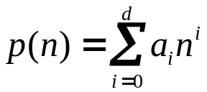
where the constants a₀, a₁, . . , , a_{d} are the coefficients of the polynomial and a_{d} ≠ 0.

A polynomial is asymptotically positive iff a_{d} > 0.

For an asymptotically positive polynomial p(n) of degree d, we have p(n) = Θ(n^{d}).

For any real constant a ≥ 0, the function nª is monotonically increasing, and for any real constant a ≤ 0, the function nª is monotonically decreasing.

We say that a function f(n) is polynomially bounded if f(n) = n^{O(1)} , which is equivalent to saying that f(n) = O(n^{k}) for some constant k.

The rates of growth of polynomials and exponentials can be related by the following fact. For all real constants a and b such that a > 1, 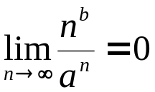
from which we can conclude that 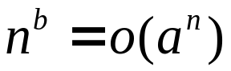

Thus, any positive exponential function grows faster than any polynomial.

Using e to denote 2.71828 . . ., the base of the natural logarithm function, we have for all real x,
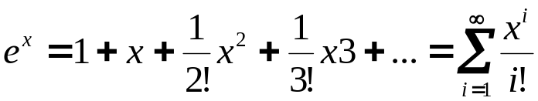 where "!" denotes the factorial.

For all real x we have the following inequality:
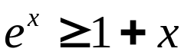 where equality holds only when x = 0.

When |x| ≤ 1, we have the approximation
1 + x ≤ e^{x} ≤ 1 + x + x²

When x -> 0, the approximation of e^{x} by 1 + x is quite good: e^{x} = 1 + x + Θ(x²) .

(In this equation, the asymptotic notation is used to describe the limiting behavior as x -> 0 rather than as x -> ∝.). We have for all x, 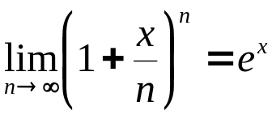
An important notational convention we shall adopt is that logarithm functions will apply only to the next term in the formula, so that lg n + k will mean (lg n) + k and not lg(n +k).

For n > 0 and b > 1, the function log_{b} n is strictly increasing 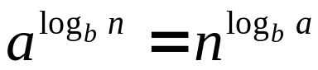 We will use this identity a lot!

Since changing the base of a logarithm from one constant to another only changes the value of the logarithm by a constant factor, we shall often use the notation "lg n" when we don't care about constant factors, such as in O-notation.

Computer scientists find 2 to be the most natural base for logarithms because so many algorithms and data structures involve splitting a problem into two parts.

There is a simple series expansion for ln(l + x) when
|x| < 1: 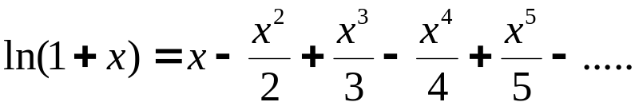.
We also have the following inequalities for x > -1:
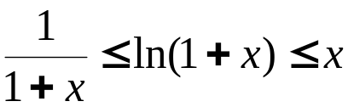, where equality holds only for x = 0.

We say that a function f(n) is polylogarithmically bounded if
f(n) = lg^{O(l)} n.

We can relate the growth of polynomials and polylogarithms by substituting lg n for n and 2ª for a in equation (2.5), yielding 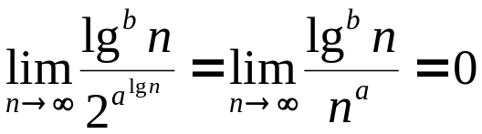
From this limit, we can conclude that for any constant a > 0.
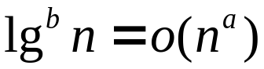

Thus, any positive polynomial function grows faster than any polylogarithmic function.

Stirling's approximation,

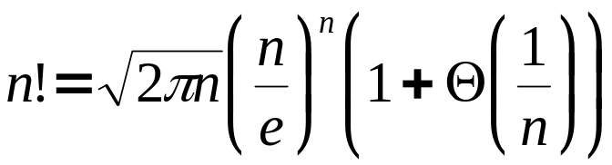,
where e is the base of the natural (neperian) logarithms, gives us a tighter upper bound, and a lower bound as well.

Using Stirling's approximation, one can prove

n! = o(n^{n}),
n! = ω(2^{n}),
lg(n!) = Θ(n lg n).

The following bounds also hold for all n:

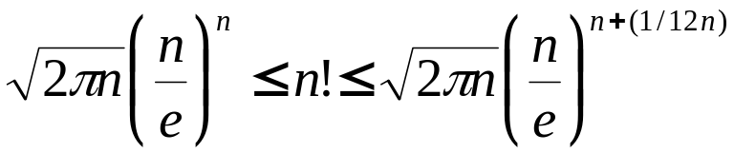

The iterated logarithm function

We use the notation lg* n (read "log star of n ") to denote the iterated logarithm, which is defined as follows.
Let the function lg^{(i)} n be defined recursively for nonnegative integers i as

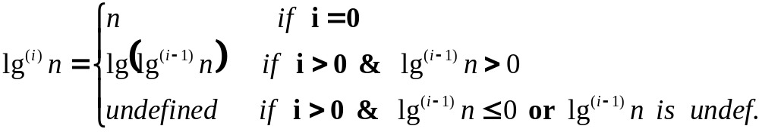

Be sure to distinguish lg^{(i)} n (the logarithm function applied i times in succession, starting with argument n) from lg^{i} n (the logarithm of n raised to the i^{th} power).

The iterated logarithm function is defined as

lg* n = min {i ≥ 0 | lg^{(i)} n ≤ 1} .

The iterated logarithm is a very slowly growing function:

lg* 2 = 1; lg* 4 = 2; lg* 16 = 3; lg* 65536 = 4;

lg*(2⁶⁵⁵³⁶) = 5.

Since the number of atoms in the observable universe is estimated to be about 10⁸⁰, which is much less than 2⁶⁵⁵³⁶, we rarely encounter a value of n such that lg* n > 5.

Iterated Function

Let c be a positive real number. The iterated function 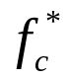 is the number of iterations (i.e. a natural number) of f required to reduce its argument to c or less, so that 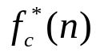is the smallest nonnegative integer k such that 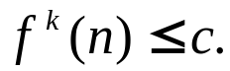

Example
Find the largest n such that lg* n = 5.

Solution
We have

1 = lg 2;
2 = lg lg 2² = lg² 4;
3 = lg lg lg 2⁴ = lg³ 2⁴ = lg³ 16
4 = lg lg lg lg 2¹⁶ = lg⁴ 2¹⁶ = lg⁴ 65,536
5 = lg lg lg lg lg 2^{65,536} = lg⁵ 2⁶⁵⁵³⁶

Example
Let g(n) = n^{1/5}, calculate g^{k}(n) and g₂*(n)

Solution
We have
g¹(n) = n^{1/5};
g²(n) = g(g(n)) = g(g¹(n)) = g(n^{1/5}) = n^{1/25}; where 25 = 5²
g³(n) = g(g(g(n))) = g(g²(n)) = g(n^{1/25}) = n^{1/125}; where 125 = 5³

in general (this is what needs to be found) the formula will be
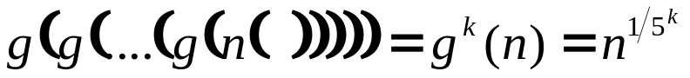

now we use the constraint g₂*(n) ≤ 2 →

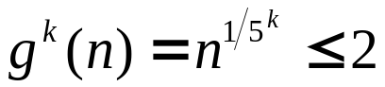→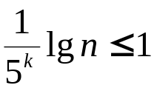→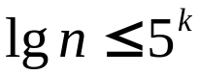→

→ 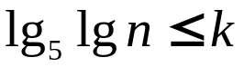→ 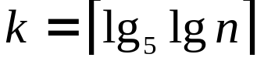

and k is the number of "iterations", that is the value of g*(n).

Fibonacci numbers
The Fibonacci numbers, which grow exponentially, are defined by the following recurrence:

F₀ = 0
F₁ = 1
F_{i} = F_{i-1} + F_{i-2} for i ≥ 2

Thus, each Fibonacci number is the sum of the two previous ones, yielding the sequence

0, 1, 1, 2, 3, 5, 8, 13, 21, 34, 55, ….

Fibonacci numbers are related to the golden ratio φ and to its conjugate φ^{c} which are given by the following formulas:
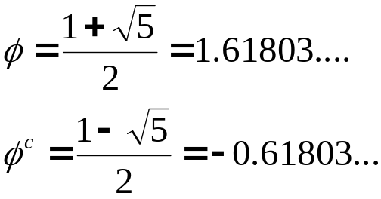
Specifically, we have 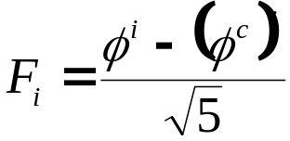

which can be proved by induction (Exercise 2.2-7).
\Since |φ^{c}| <1, we have 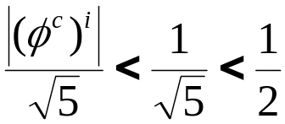,
so that the i^{th} Fibonacci number Fi is equal to 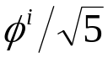 rounded to the nearest integer.

Problems to Consider

1. Let 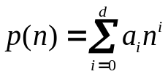 where a_{d} > 0, be a degree-d polynomial in n, and let k be a constant. Use the definitions of the asymptotic notations to prove the following properties:

a) If k ≥ d, then p(n) = O(n^{k})
b) If k ≤d, then p(n) = Ω( n^{k})
c) If k = d, then p(n) = Θ( n^{k})
d) If k > d, then p(n) = o(n^{k})
e) If k < d, then p(n) = ω( n^{k})

2. Show that (n + a)^{b} = O(n^{b})

3. Is 2^{n+1} = O(2^{n})? Is 2^{2n} = O(2^{n})?

4. (HARD!) For a function f satisfying f(n) <n, we define the function f^{(i)} recursively for nonnegative integers i by:

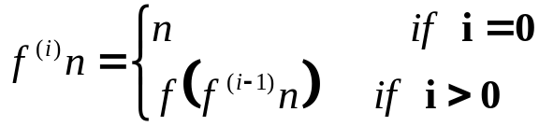
For a given constant c ∈ R# (R# is the set of real numbers), we define the iterated function g*(n) by

g*(n) = min{i ≥ 0 | f^{(i)} ≤ c},

which need not be well defined in all cases. In other words, the quantity g*(n) is the number of iterated applications of the function f required to reduce its argument down to c or less.

For each of the following functions f(n) and constants c, give as tight a bound as possible on g*(n).

f(n) | c | g*(n)
lg n | 1
n - 1 | 0
n/2 | 1
n/2 | 2
sqrt(n) | 2
sqrt(n) | 1
n^{1/3} | 2
n/lg n | 2

5. (a) Rank the following functions by order of growth, that is, find an arrangement g₁, g₂, g₃, …, g₃₀ of the functions satisfying g₁ = Ω(g₂), g₂ = Ω (g₃), …, g₂₉ = Ω (g₃₀). Partition your list into classes such that f(n) and g(n) are in the same class iff f(n) = Θ(g(n)).
(b) Give an example of a single nonnegative function f(n) such that for all functions g_{i}(n) in part (a), f(n) is neither O(g_{i}(n)) nor Ω(g_{i}(n)).

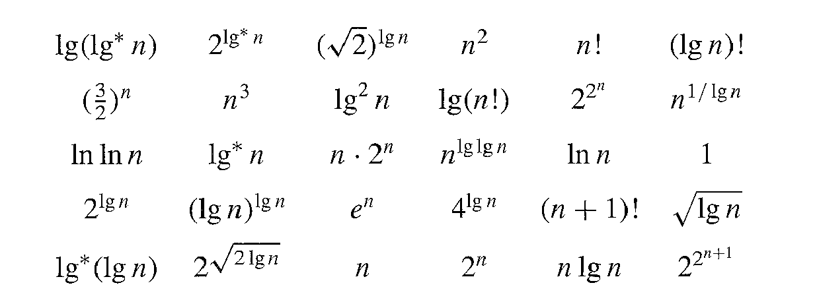

6. Relative Asymptotic Growths

Indicate, for each pair of expressions (A, B) in the table below, whether A is O, Ω, or Θ of B (skip “o” and “ω”).
Assume that k ≥ 1, e > 0, and C > 1 are constants. Your answer should be in the form of the table with “yes” or “no” written in each box.
 | A | B | O | Ω | Θ | o | ω
a | lg^{k} n | n^{ε}
b | n^{k} | c^{n}
c | √n | n^{sinπ}
d | 2^{n} | 2^{n/2}
e | n^{lgc} | c^{lgn}
f | lg(n!) | lg(n^{n})

3.3 The master theorem
The master method depends on the following theorem.

Theorem 3.2 (Master theorem)
Let a ≥ 1 and b > 1 be constants, let f(n) be a function, and let T(n) be defined on the nonnegative integers by the recurrence
T(n) = aT(n/b) + f(n) ,
where we interpret n/b to mean either ⎣n/b⎦ or ⎡n/b⎤,

Then T(n) can be bounded asymptotically as follows.

1. If f(n) = 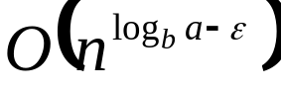 for some constant ε > 0, then T(n) = 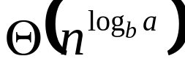

2. If f(n) = 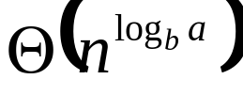 then T(n) = 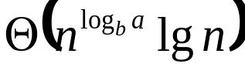

3. If f(n) = 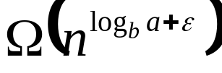 for some constant ε > 0, and if af(n/b) ≤ cf(n) for some constant c < 1 and all sufficiently large n, then T( n) = 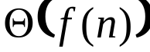

Before applying the master theorem to some examples, let's spend a moment trying to understand what it says.

In each of the three cases, we are comparing the function f(n) with the function 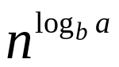.

Intuitively, the solution to the recurrence is determined by the larger of the two functions.

In case 1, the function is the larger of the two.

In case 3, the function f(n) is the larger of the two.

In case 2, the two functions are the same size, we multiply by a logarithmic factor, and the solution is T(n) = = 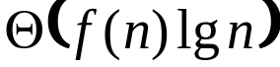.

Beyond this intuition, there are some technicalities that must be understood.

In the first case, not only must f(n) be smaller than , it must be polynomially smaller; that is, f( n) must be asymptotically smaller than by a factor of n^{ε} for some constant ε > 0.

In the third case, not only must f(n) be larger than , it must be polynomially larger and in addition satisfy the "regularity" condition that af(n/b) ≤ cf(n), condition satisfied by most of the polynomially bounded functions that we shall encounter.

It is important to realize that the three cases do not cover all the possibilities for f(n).

There is a gap between cases 1 and 2 when f(n) is
smaller than but not polynomially smaller.

Similarly, there is a gap between cases 2 and 3 when f(n) is larger than but not polynomially larger.

If the function f(n) falls into one of these gaps, or if the regularity condition in case 3 fails to hold, the master method cannot be used to solve the recurrence.

Using the master method

To use the master method, we simply determine which case (if any) of the master theorem applies and write down the answer.

Example 1
Solve T(n) = 9T(n/3) + n .

For this recurrence, we have a = 9, b = 3, f(n) = n, and thus = 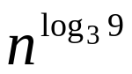 = 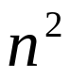

Since f(n) = n = , where ε = 1, we can apply case 1 of the master theorem and conclude that the solution is T(n) = 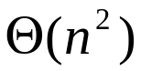

Example 2
Solve the recurrence T(n) = T(2n/3) + 1.

For this recurrence we have a = 1, b = 3/2, f(n) = 1 = n⁰, and 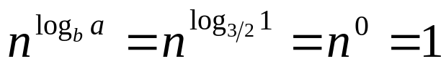. Case 2 applies, since f(n) = 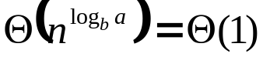 and thus the solution to the recurrence is T(n) = 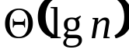

Example 3
Solve the recurrence T(n) = 3T(n/4) + n².

For this recurrence we have a = 3, b = 4, f(n) = n², and 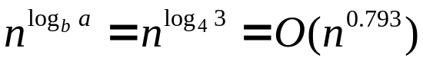.

Since we have to have f(n) = , a lower bound, then ε > 0 cannot be such that the exponent of n exceeds 1 (because as seen in class n < nlgn < n²), that is, 0 < ε < 0.207 (0.207 = 1 – 0.793).

Selecting ε = 0.2, case 3 applies if we can show that the
regularity condition holds for f(n). For sufficiently large n,

af(n/b) = 3(n/4) lg(n/4) ≤ (3/4)nlgn = cf(n) for c = 3/4.

Consequently, by case 3, the solution to the recurrence is T( n) = 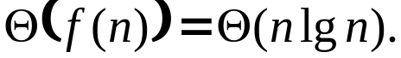

Example 4
Solve the recurrence T(n) = 3T(n/4) + nlgn.

For this recurrence we have a = 3, b = 4, f(n) = nlgn, and .

Since we have to have f(n) = , a lower bound, then ε > 0 cannot be such that the exponent of n exceeds 1 (because as seen in class n < nlgn < n²), that is, 0 < ε < 0.207 (0.207 = 1 – 0.793).

Selecting ε = 0.2, case 3 applies if we can show that the
regularity condition holds for f(n). For sufficiently large n,

af(n/b) = 3(n/4) lg(n/4) ≤ (3/4)nlgn = cf(n) for c = 3/4.

Consequently, by case 3, the solution to the recurrence is T( n) =

Notice that the ratio
f(n)/ = (nlgn)/n^{0.793} = n^{0.207}lg n
is asymptotically (grows with n) and also polynomially (grows with n^{ε}) larger than n^{0.793} for any positive constant ε (in this case ε = 0.207).

Example 5
The master method does not apply in some cases. To show this with an example , consider the recurrence

T(n) = 2T(n/2) + nlgn,

which seems to have the proper form: a = 2, b = 2, f(n) = nlgn, and = n.

It seems that case 3 should apply, since f(n) = nlgn is asymptotically larger than = n but not polynomially larger.

The ratio f(n)/= (nlgn)/n = lg n is asymptotically less than n^{ε} for any positive constant ε.

Consequently, the recurrence falls into the gap between case 2 and case 3 and it should be solved step by step as we saw earlier.

Exercises

1. The recurrence 7T(n/2) + n² describes the running time of an algorithm A. A competing algorithm A’ has a running time of aT’(n/4) + n². What is the largest integer value of a such that A’ is asymptotically faster than A?

2. Can the master method be applied to the recurrence T(n) = 4T(n/2) + n²lg n? Why or why not? Give an asymptotic upper bound for this recurrence.

Bounding Summations

(Exercising Mathematical Induction & Binomial Theorem)

Example 1:
Prove that 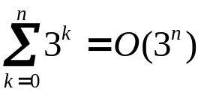

Consider 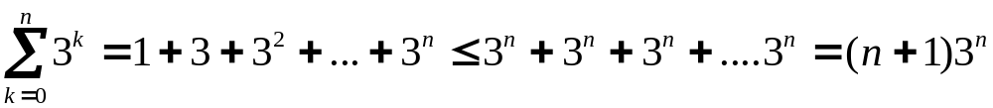

but the constant in front of 3^{n} is a function of n and thus is not a constant. What we do is then to use mathematical induction.

We assume that the thesis is valid for n and try to prove that is valid for n+1.

To say the summation is O(3^{n}) means that the summation is ≤ c3^{n} for some constant c. For the initial condition n = 0, we have that 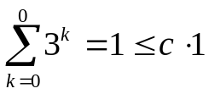 as long as c > 1. Assuming that the bound holds for n, let’s us prove that it holds for n+1. We write

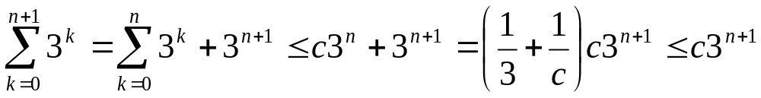

as long as we take (1/3 + 1/c) ≤ 1, or c ≥ 3/2. Thus, changing n+1 to n we get
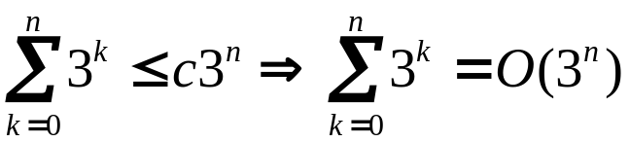

Example 2:
Prove that 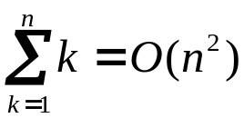
Write 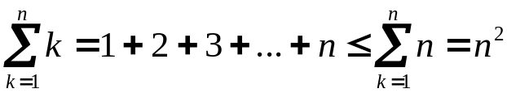

In general: 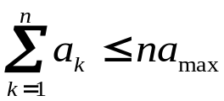where 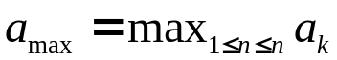

Example 3:
Consider the series 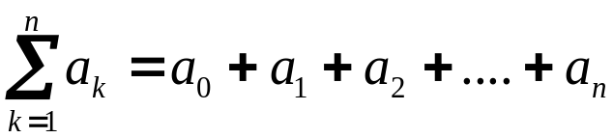.

Assume that a_{k+1}/a_{k} ≤ r for all k ≥ 0, where r < 1 is a constant.

In general we'll find out that a_{k} ≤ a ₀r^{k}, and thus

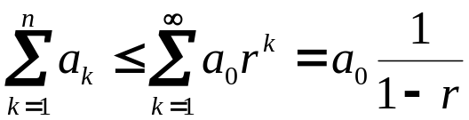

Example 4: Bound 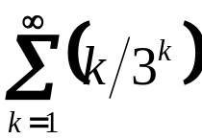

The first term is (1/3) and the ratio of the k+1 and the k^{th} terms is (1/3)(k+1)/k ≤ 2/3 for all k ≥ 1.
Thus each term is bounded by (1/3)(2/3)k so that

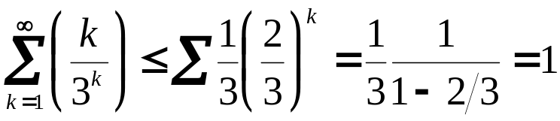

Example 5:
Find a bound for 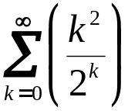

The ratio of two consecutive terms is

(k+1)²/2k² ≤ 8/9 for k ≥ 3,

then we split the summation as follows:

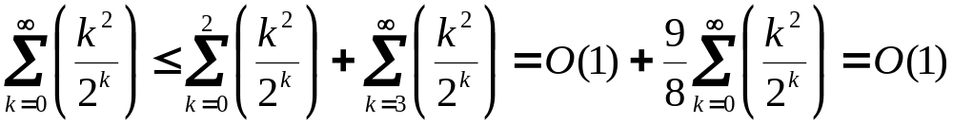

because the second summation is a decreasing geometric series.

Example:
Use integrals to approximate a function.

For a monotonically increasing function:

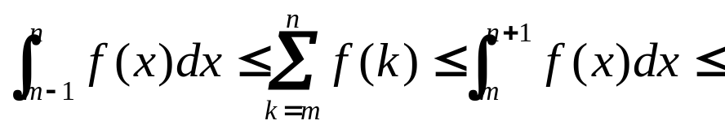

For a monotonically decreasing function we get

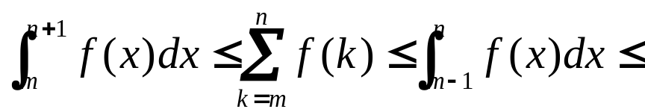

Give a tight estimate for 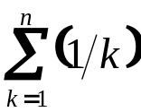

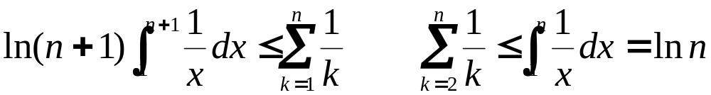

which yields the bound 